# Week 5:

Using the “Fn” function we are finding the shortest path to reach the corners of the maze. Fn takes Breadth's first search algorithm as the parameter and implements it to find the shortest path. We used the Manhattan distance function to calculate the heuristic value associated with each node, to implement A* algorithm.

After implementing both algorithms we observed that even though both of them have the same cost but A* algorithm is more efficient as it expands less number of nodes. Breadth First search expands a lot more unnecessary nodes.

**Question 5:**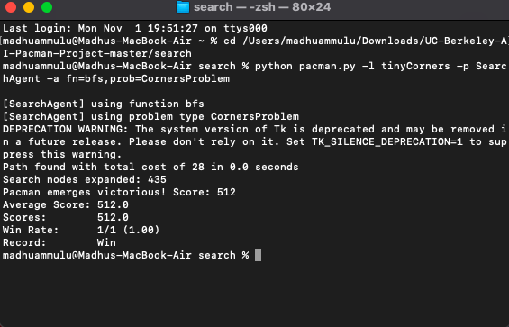

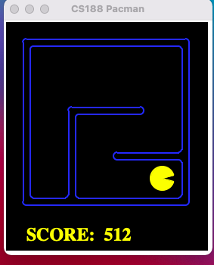

2.

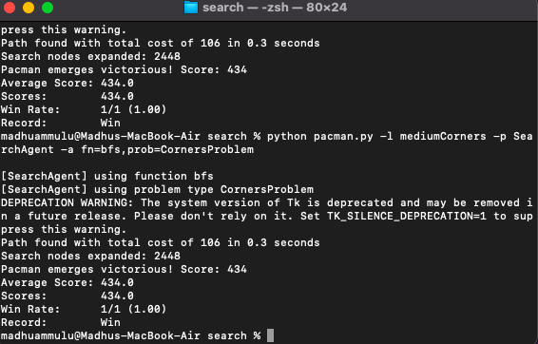

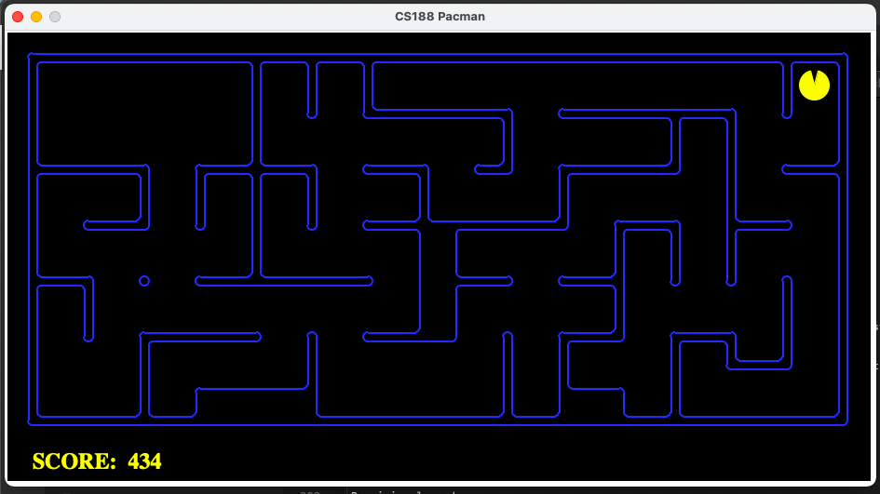

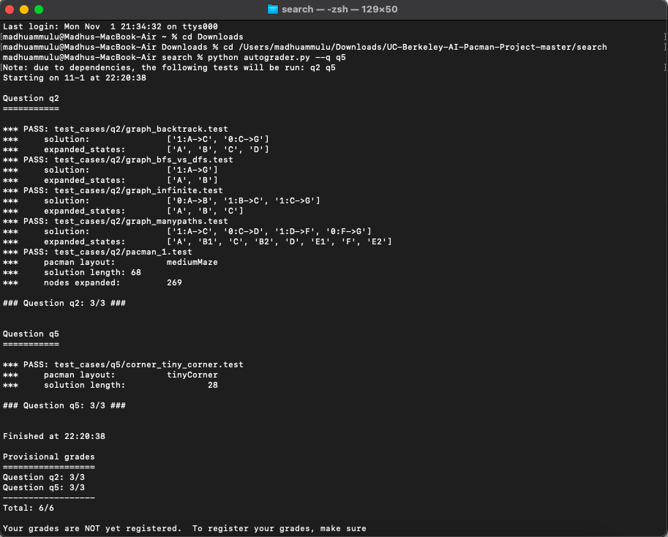**Question 6 :**

